**Automation in deployment using AWS Server**

Created AWS server

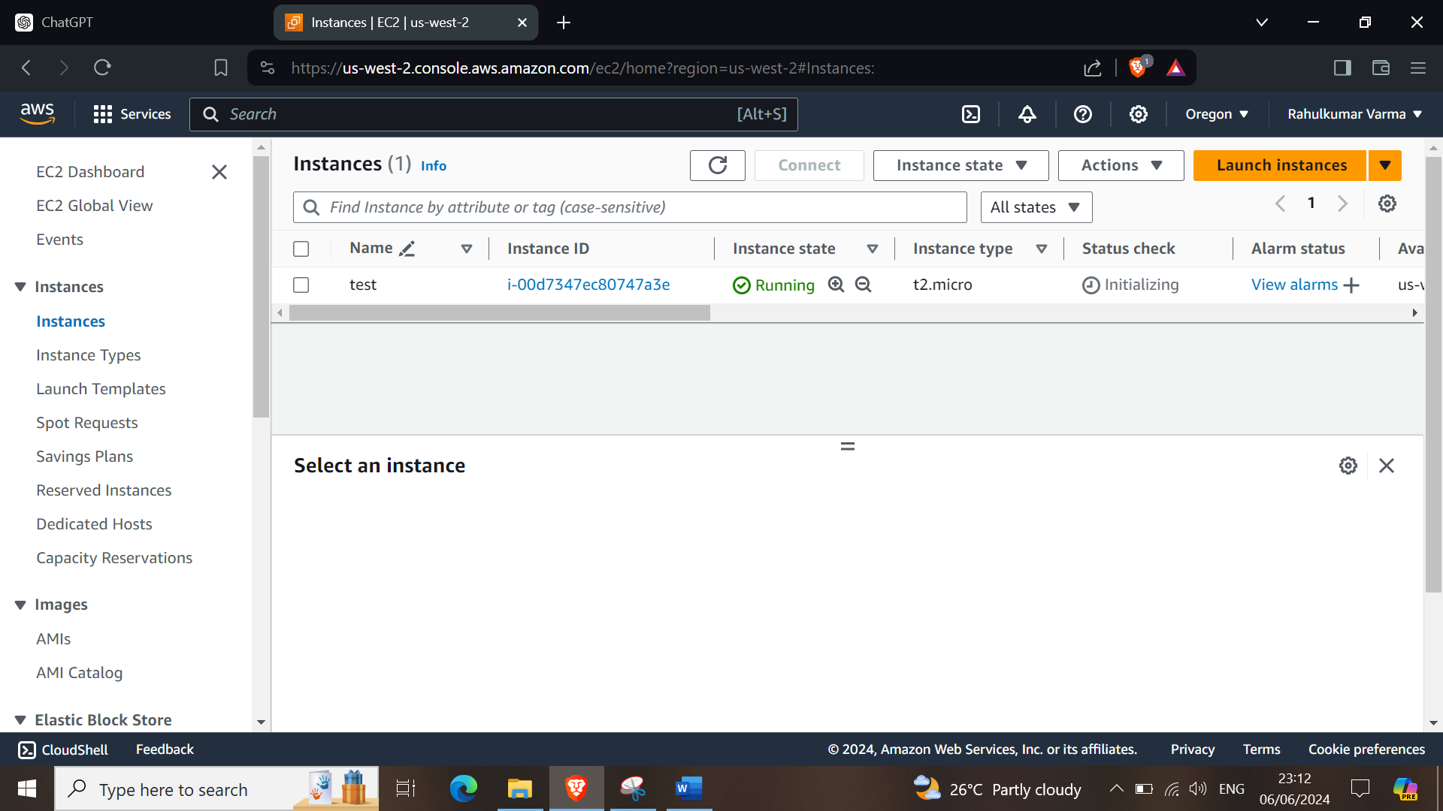

Using public IP connected to windows PowerShell

ssh -i jun3.pem ubuntu@20.115.93.167

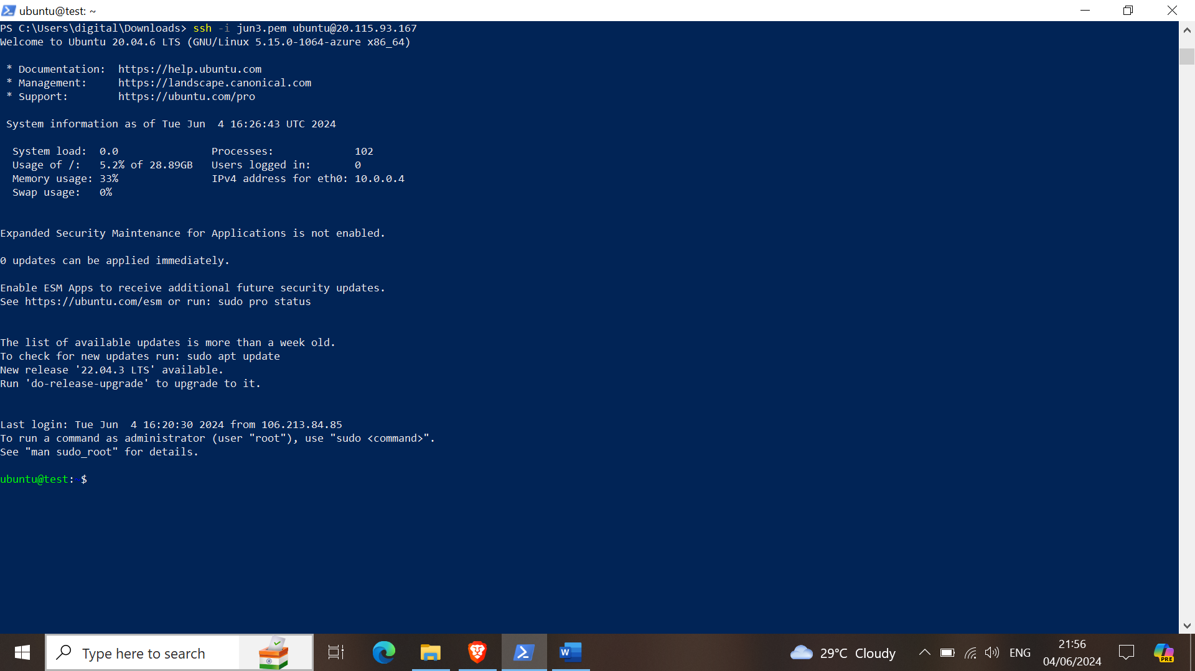

Update & upgrade the preinstalled packages of server

apt update -y && apt upgrade -y

Install jdk for java

apt install openjdk-11-jdk -y

Install Jenkins

curl -fsSL https://pkg.jenkins.io/debian-stable/jenkins.io-2023.key | sudo tee \

/usr/share/keyrings/jenkins-keyring.asc > /dev/null

echo deb [signed-by=/usr/share/keyrings/jenkins-keyring.asc] \

https://pkg.jenkins.io/debian-stable binary/ | sudo tee \

/etc/apt/sources.list.d/jenkins.list > /dev/null

sudo apt update -y

sudo apt install jenkins -y

Get Jenkins password

cat /var/lib/jenkins/secrets/initialAdminPassword

Login Jenkins

Serch http://<public ip>:8080/ in browser And use Jenkins password to login in Jenkins

Then Create User in Jenkins and start Jenkins

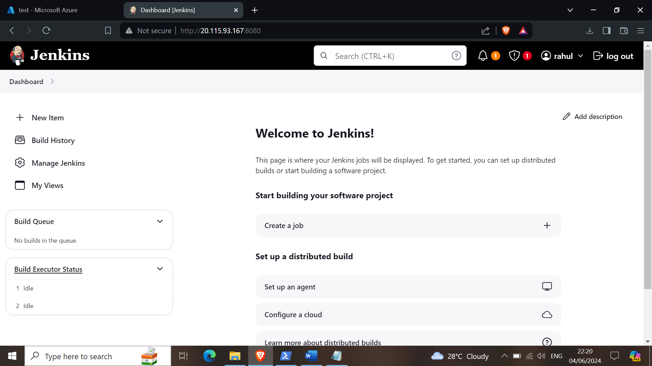

Now in manage Jenkins -> tools -> add maven

-> plugins -> availabel plugins -> search & install

1. build pipeline

2. maven integration

3. deploy to container

4. copy artifact

Install tomcat & tomcat admin

apt install tomcat9 -y

apt install tomcat9-admin -y

Change tomcat port 8080 to 8090

vi /etc/tomcat9/server.xml

Add user roll for tomcat

vi /var/lib/tomcat9/conf/tomcat-users.xml

Add below content in above file at the end of file (Change username ana password as you want)

<role rolename="manager-gui"/>

<user username="tomcat" password="tomcat" roles="manager-gui, manager-gui, manager-script, manager-jmx, manager-status"/>

Restart tomcat

service tomcat9 restart

service tomcat9 status

Login Tomcat

Serch http://<public ip>:8090/manager/ in browser

And use tomcat username and password to login

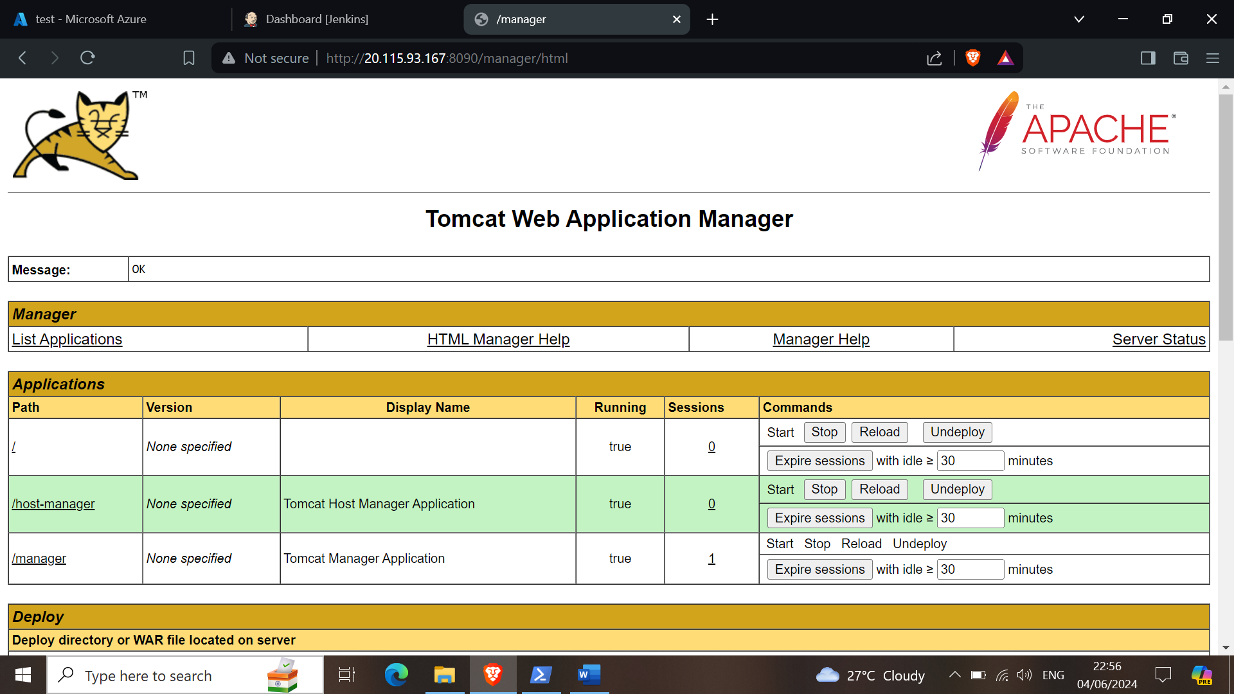

Create test Job in jenkins

Create job (maven) -> Hello-world-test -> git url and maven "test"

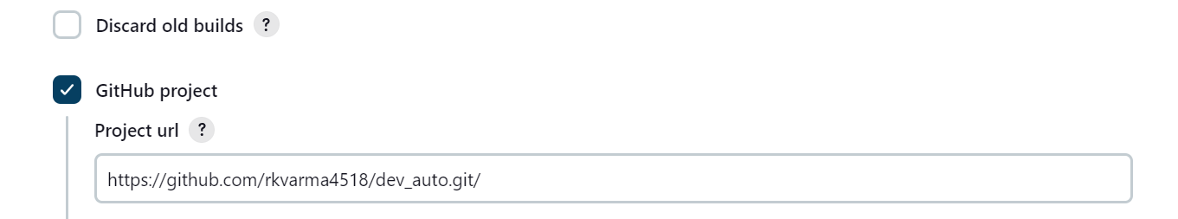

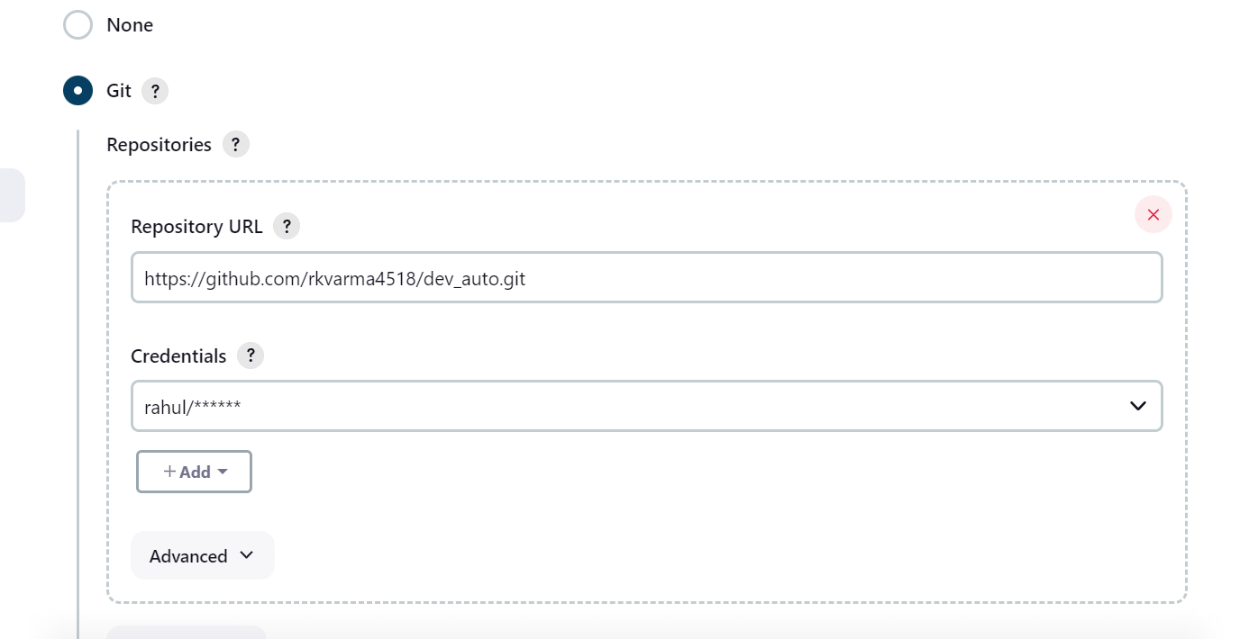

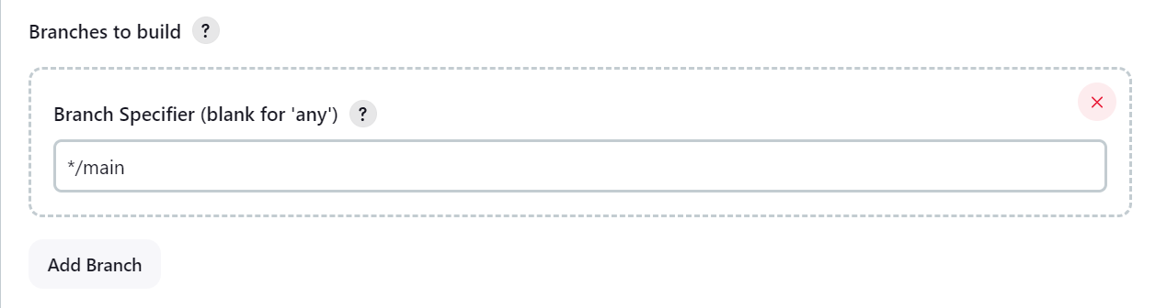

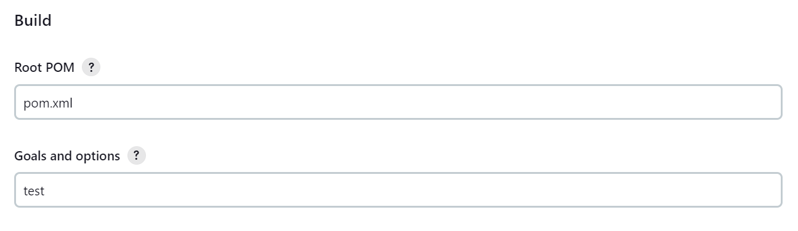

Create job (maven) -> Hello-world-build -> git url and maven "install"







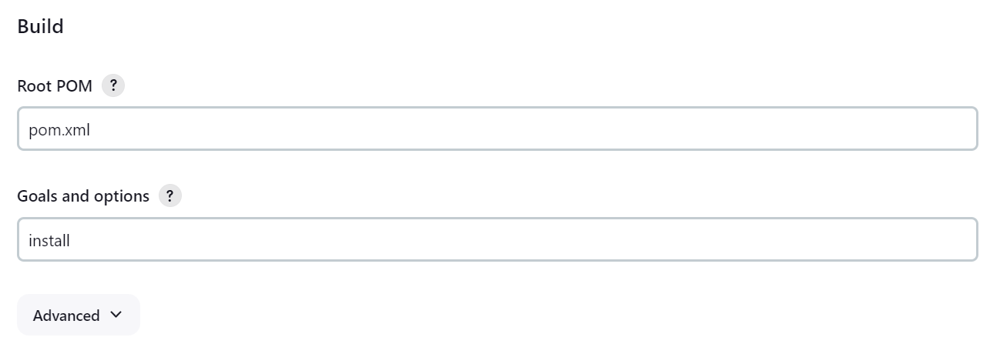

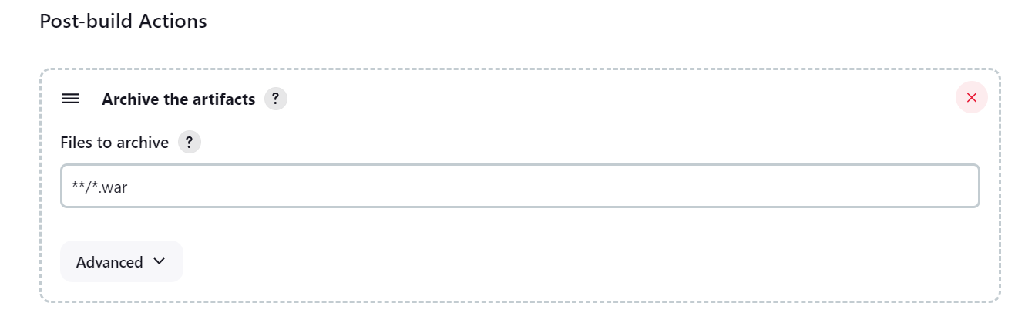

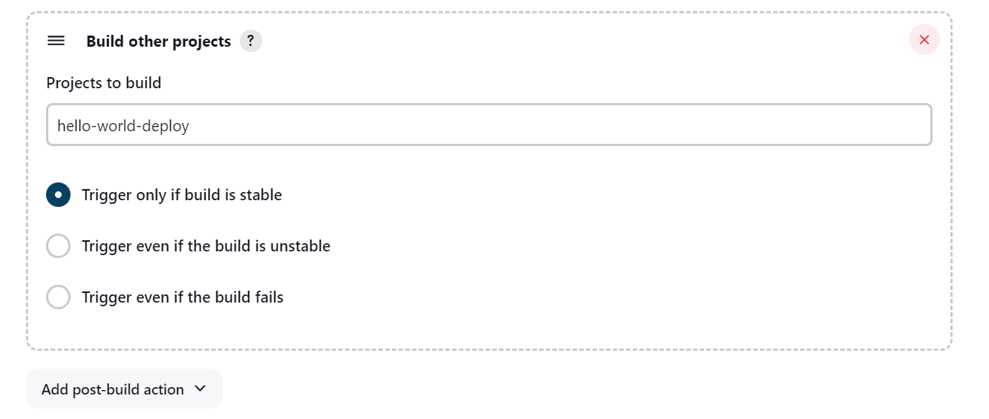

Create job (freestyle) -> Hello-world-deploy -> copy artifact & deploy to war

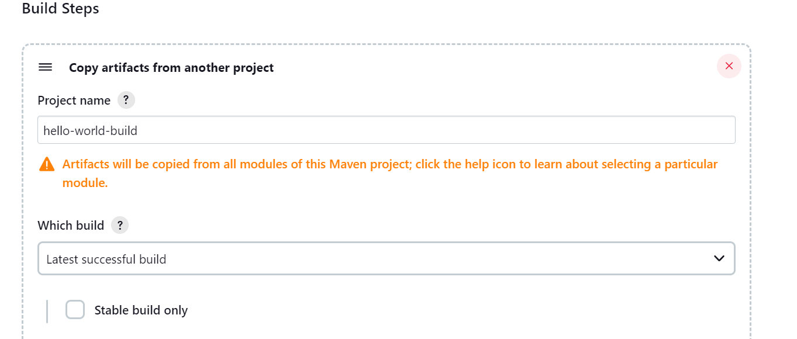

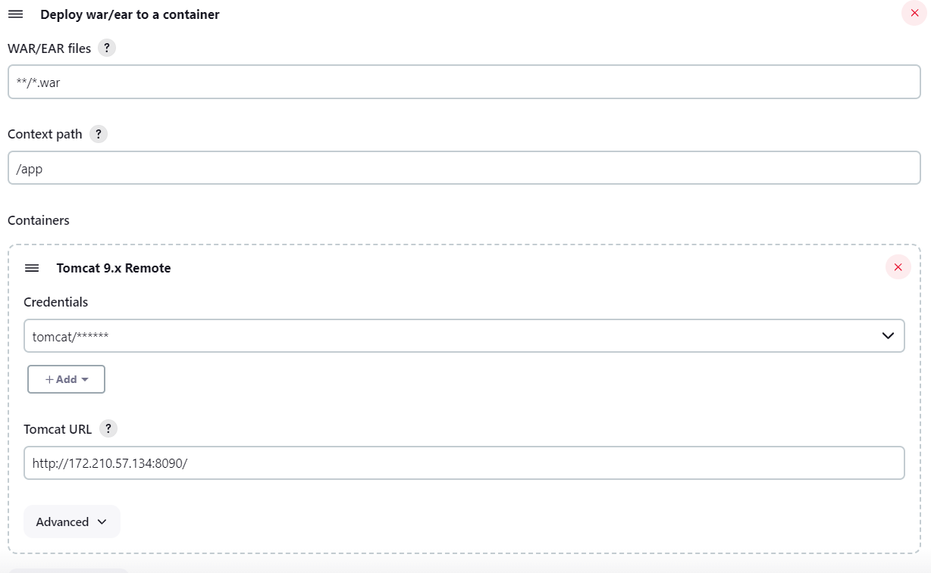

Add dependency

In hello-world-test

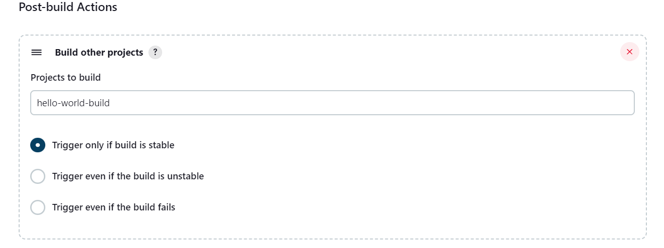

In hello-world-build

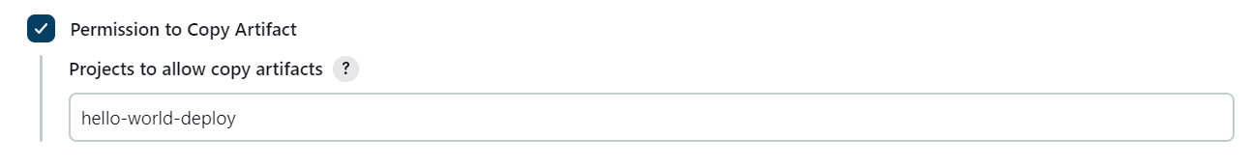

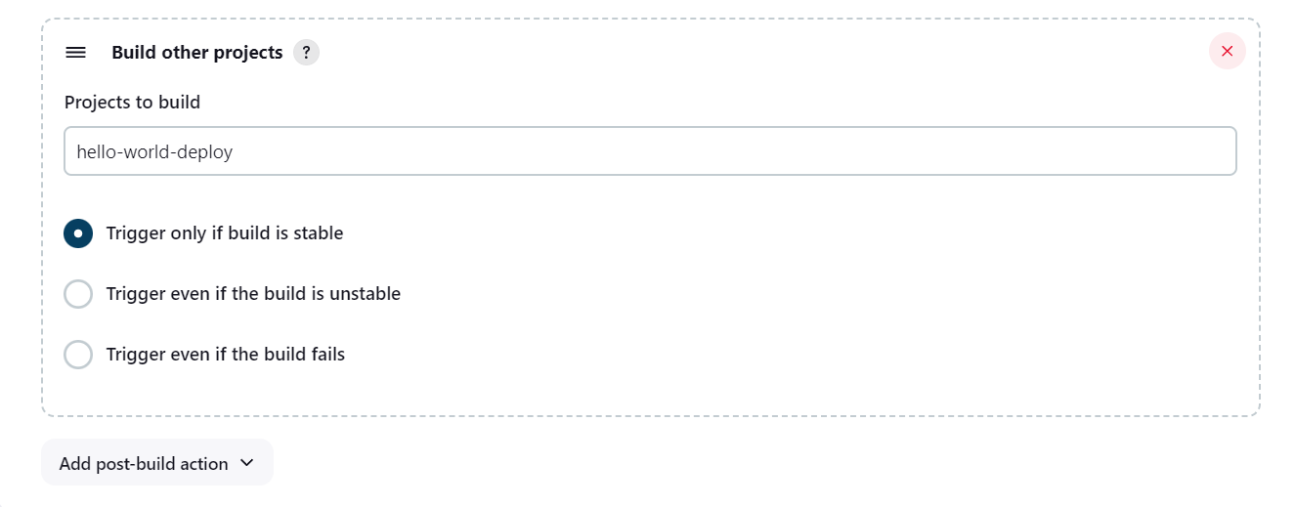

Add webhooks to redirect changes from GitHub

Github project -> settings -> webhooks -> add webhook

Payload url -> <http://172.210.57.134:8080/github-webhook/>

Content type -> application/json

Where

172.210.57.134 - public ip

8080 – Jenkins port

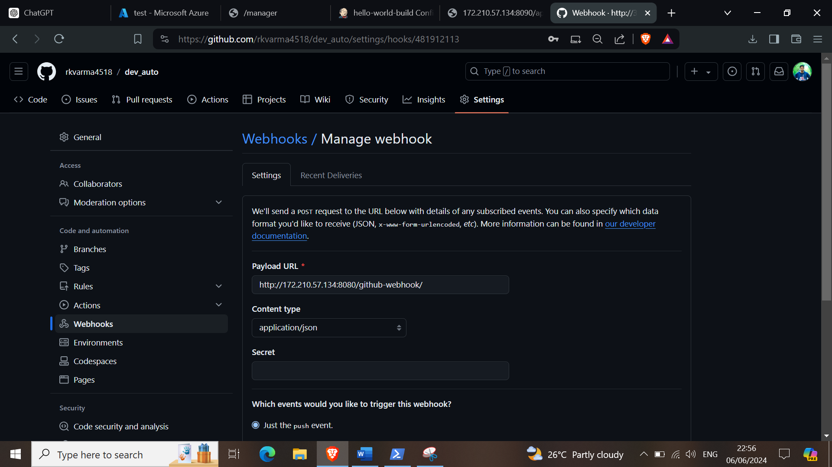

To create pipeline

Jenkins -> new view -> hello-world

-> type - build pipeline

create

-> select initial job - hello-world-test

Result

